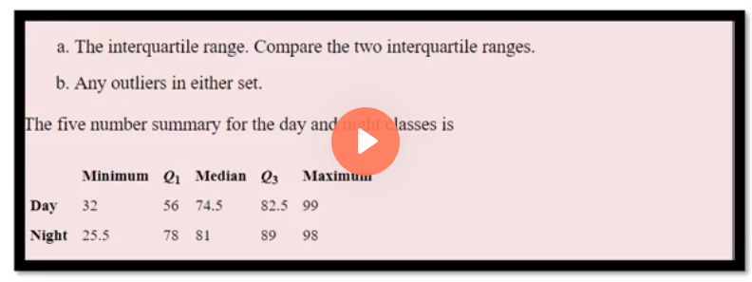

IQR = Q3-Q1

Day IQR = 82.5-56=26.5

Night IQR = 89-78 =11

Day:

Minimum = 32 , maximum is 99

Lower outlier = Q1- (1.5\* IQR) = 56 – (1.5 \* 26.5) =56- 39.75 = 16.25

Higher outlier = Q3+(1.5\* IQR) = 82.5 + (1.5\*26.5)=82.5+39.75 =122.25

Here we don’t have lower outlier minimum value is greater than 16.25

We don’t have higher outlier also because maximum value is not greater than 122.25

Night :

Minimum is 25.5 ,maximum is 98

Lower outlier = Q1- (1.5\* IQR) = 78 – (1.5 \* 11) =78- 16.5 = 61.5

Higher outlier = Q3+(1.5\* IQR) = 89+ (1.5\*11)=89+16.5 =105.5

Here we have lower outlier because lower value 25.5 is lesser than the lower outlier range 61.5

So we have to replace the value with 61.5

Maximum value is less than the higher outlier range so so higher outlier